***ANALYZING THE PERFORMANCE & EFFICIENCY OF THE RADISSON HOTELS USING DATA VISUALIZATION TECHNIQUES:***

### **Define Problem / Problem Understanding:**

### **Specify The Business Problem**

Radisson owns multiple five-star hotels across India. They have been in the hospitality industry for the past 100 years. Due to strategic moves from other competitors and ineffective decision-making in management, Radisson is losing its market share and revenue in the luxury/business hotels category. As a strategic move, the managing director of Radisson wanted to incorporate Business and Data Intelligence in order to regain their market share and revenue. Our task is to create an analytics dashboard & story to provide them insights to make better business decisions.

### **Business Requirements**

The business requirements for analyzing the performance and efficiency of Radisson Hotels include identifying KPIs, comparing performance across different hotels, identifying patterns and trends over time, identifying affecting factors, creating interactive dashboards and reports, identifying areas for improvement, making data-driven decisions, comparing to industry average and creating forecasting models for future performance. The ultimate goal is to gain insights and improve performance through data visualization techniques.

**Literature Survey:**

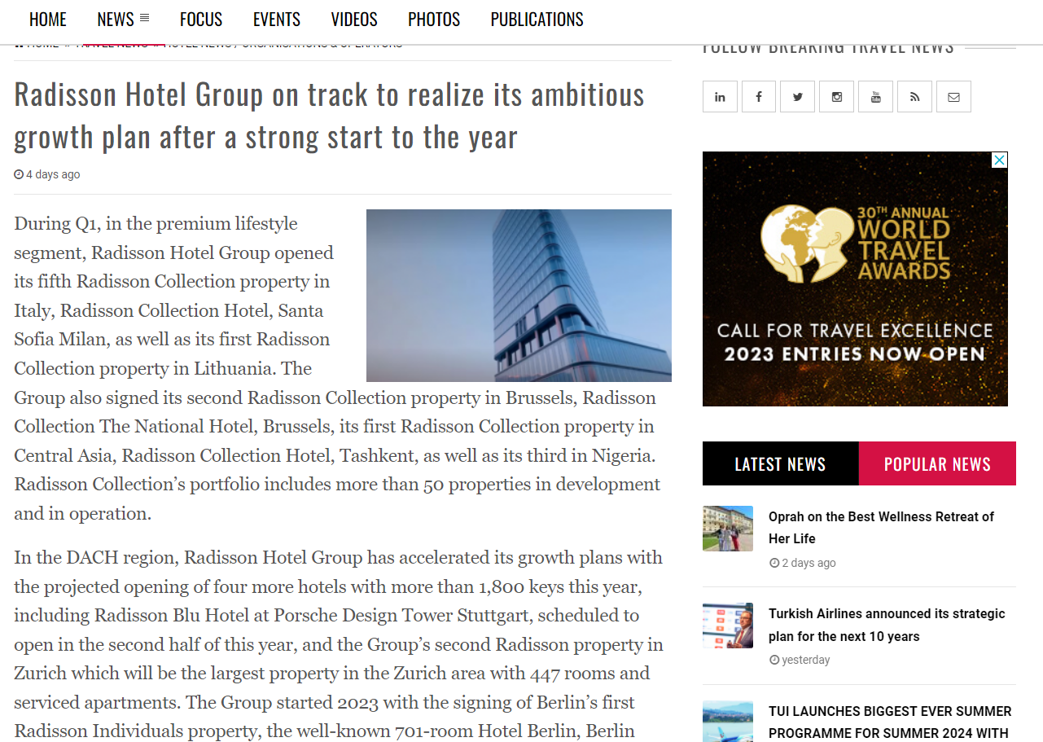

**Social and Buisness Impact:**

Radisson Hotel Group is making efforts to reduce our carbon, energy, water, and waste footprint as part of Think Planet. We aim to reduce the negative impact of our business on the planet, enhance our ability to deliver the value our customers expect and protect valuable natural resources for future generations.

***Data Collection & Extraction from Database***

Data collection is the process of gathering and measuring information on variables of interest, in an

established systematic fashion that enables one to answer stated research questions, test hypotheses, and evaluate outcomes and generate insights from the data.

***COLLECTION OF DATASET:***

We have been collecting data from various sources and examples of collecting data from various sources.

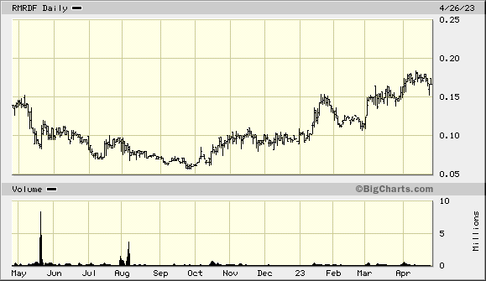

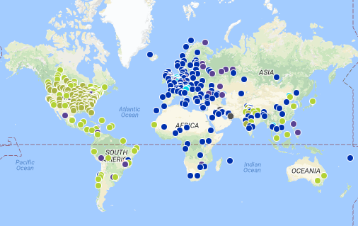

### **Understand The Data**

Data contains all the meta information regarding the columns described in the CSV files. we have provided 5 CSV files:

1. dim_date  
2. dim_hotels  
3. dim_rooms  
4. fact_aggregated_bookings

5. fact_bookings

***Storing Data in DB & Perform SQL Operations***

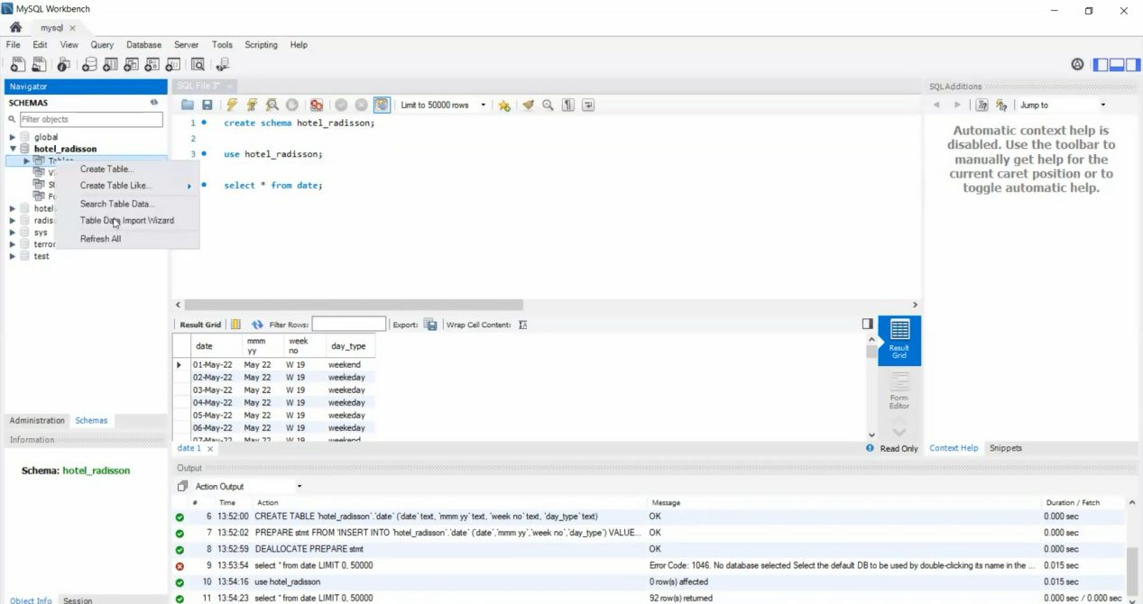

***CONNECT DB WITH TABLEAU:***

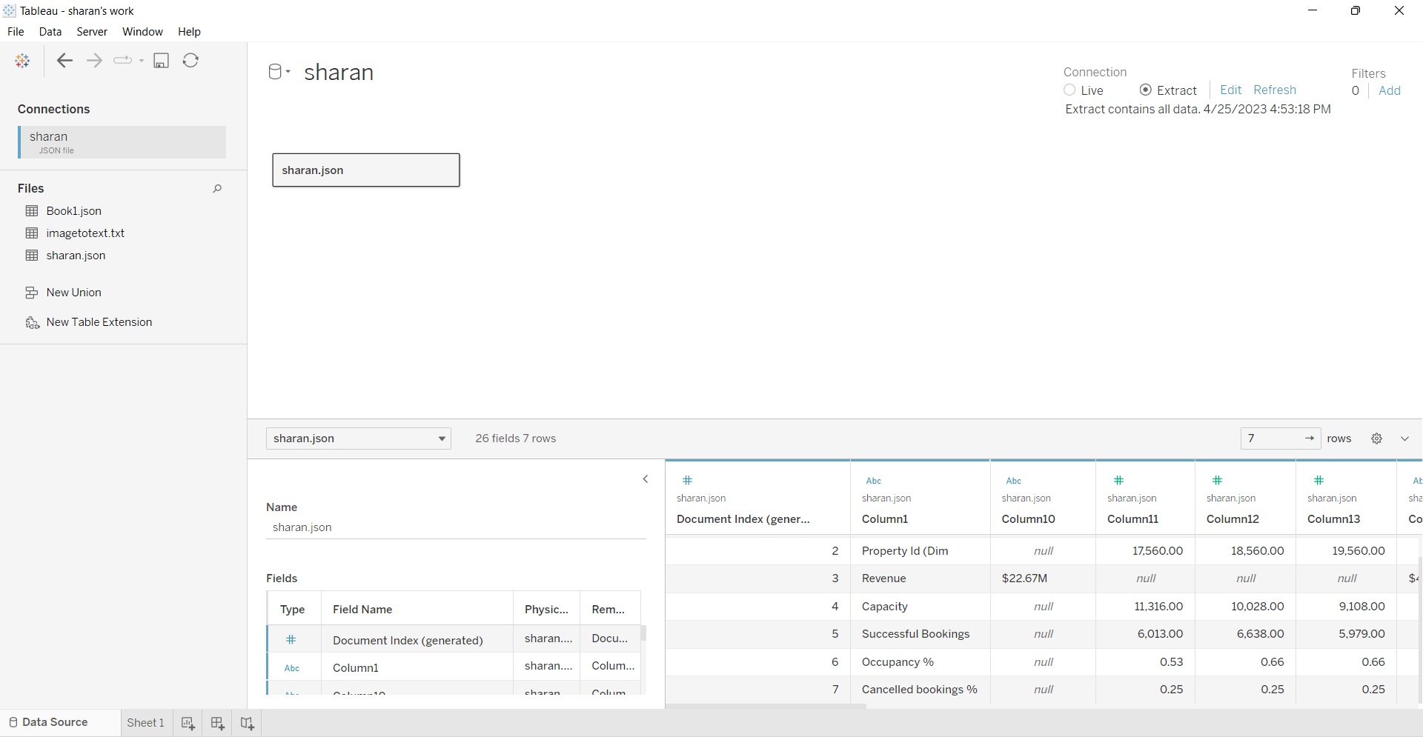

***Data Preparation***

***Prepare the Data for Visualization***

Preparing the data for visualization involves cleaning the data to remove irrelevant or missing data, transforming the data into a format that can be easily visualized, exploring the data to identify patterns and trends, filtering the data to focus on specific subsets of data, preparing.

the data for visualization software, and ensuring the data is accurate and complete. This process helps to make the data easily understandable and ready for creating visualizations to gain insights into the performance and efficiency.

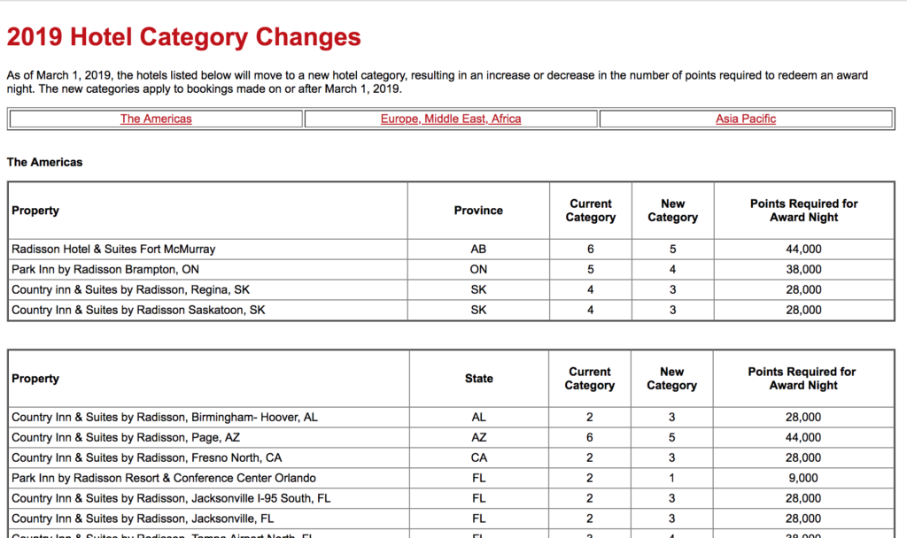

### **Data Visualization**

Data visualization is the process of creating graphical representations of data in order to help people understand and explore the information. The goal of data visualization is to make complex data sets more accessible, intuitive, and easier to interpret. By using visual elements such as charts, graphs, and maps, data visualizations can help people quickly identify patterns, trends, and outliers in the data.

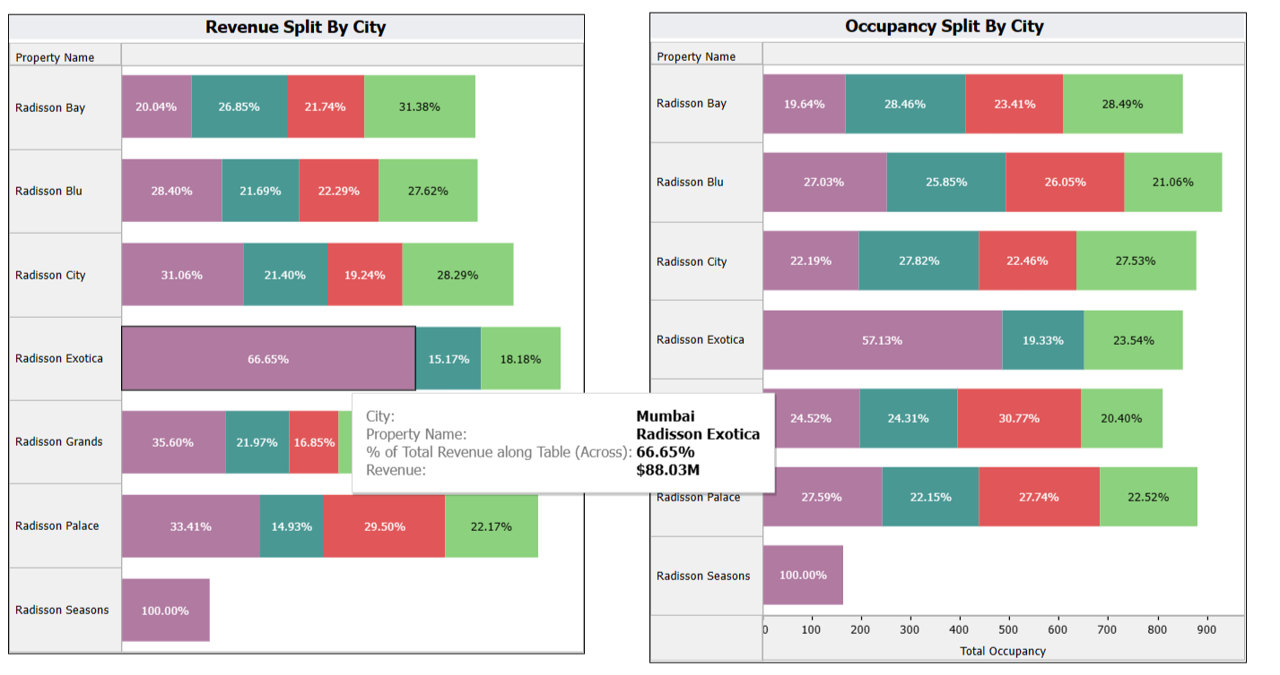

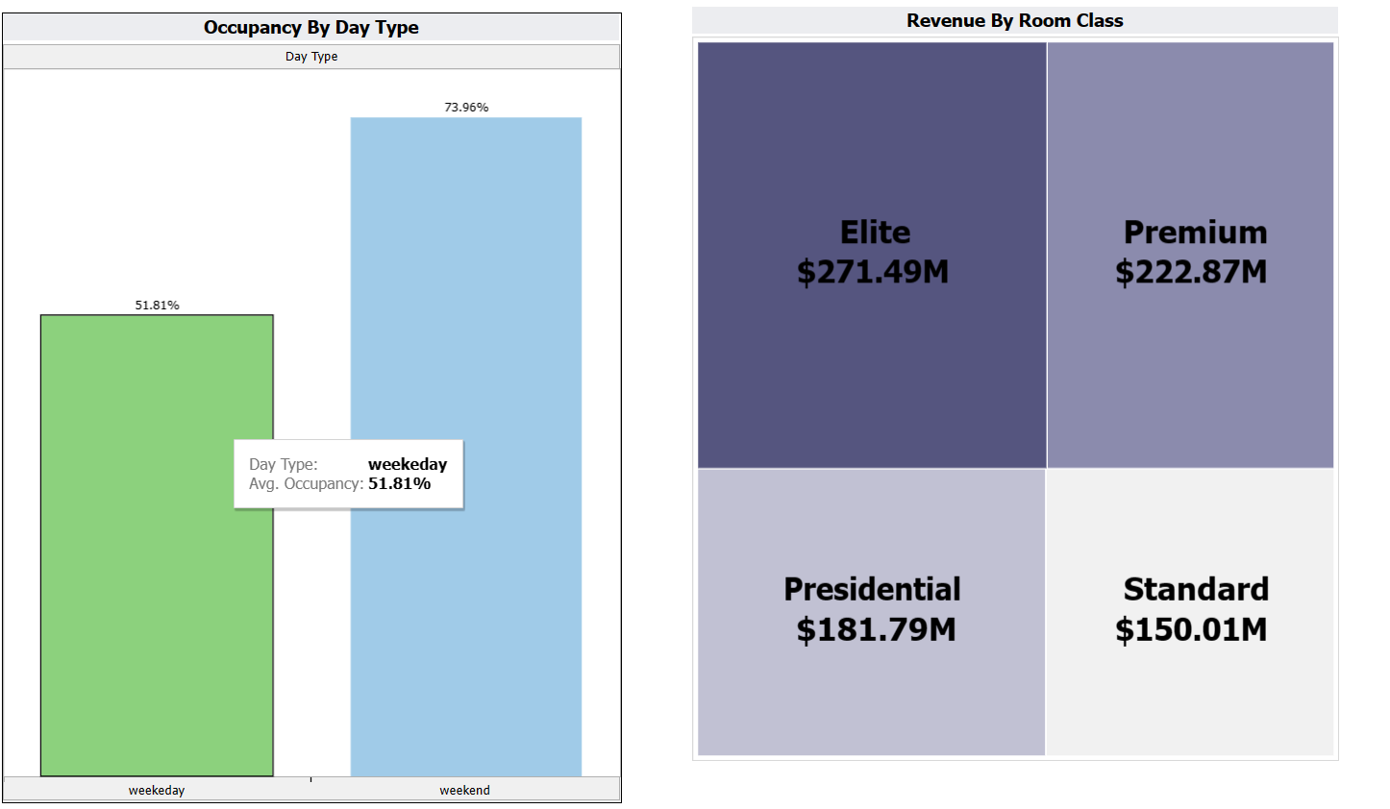

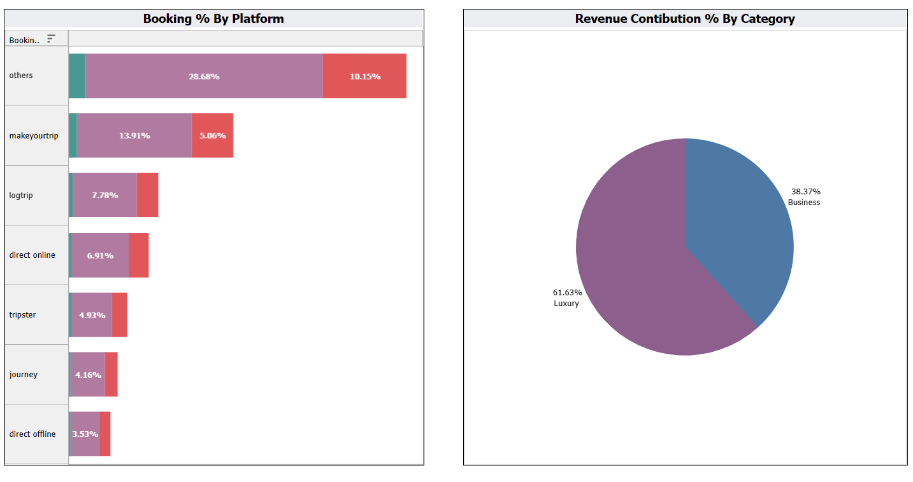

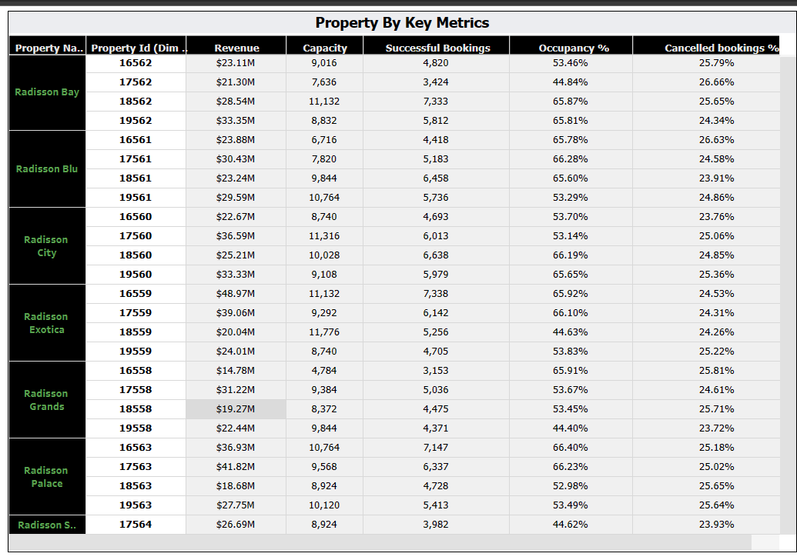

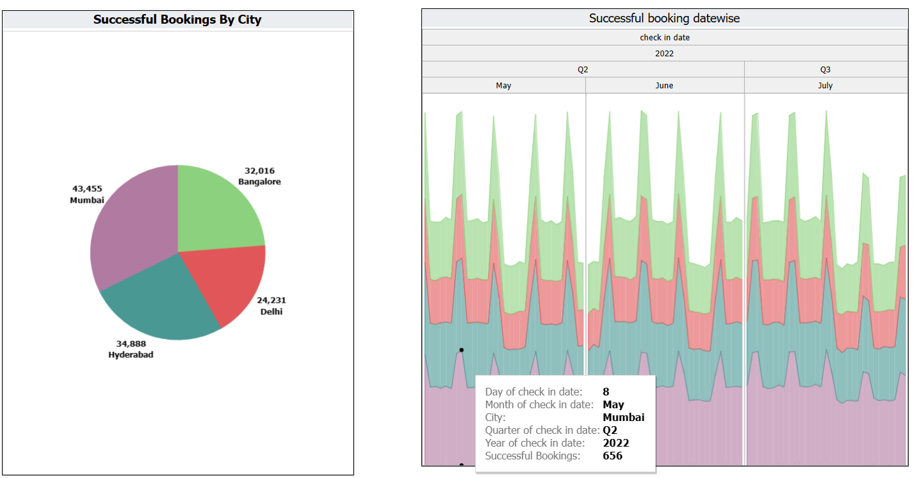

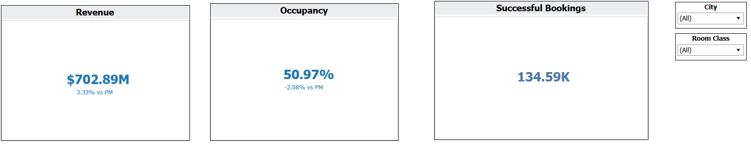

### **Dashboard**

A dashboard is a graphical user interface (GUI) that displays information and data in an organized, easy-to-read format. Dashboards are often used to provide real-time monitoring and analysis of data, and are typically designed for a specific purpose or use case. Dashboards can be used in a variety of settings, such as business, finance, manufacturing, healthcare, and many other industries. They can be used to track key performance indicators (KPIs), monitor performance metrics, and display data in the form of charts, graphs, and tables.

***Radisson Analysis Story:***

